Art Assets Brief for Clumsy Bat

by

Brave Llama Games

Contents

Overview 1

Feedback: 2

Additional Art Assets 6

List A 6

Main Menu Buttons 6

Crystal Level Button 7

Nomee button 8

List B 8

Dash button 8

Normal Level Button 8

Crystals 8

Document Control 10

# Overview

The purpose of this document is to outline the main focus of the final art pass for Clumsy Bat. These requirements are based on:

* user feedback
* replacing existing placeholder assets
* new or previously unimplemented game mechanics

# Feedback:

**Feedback 1:** *The dark colours for the edges blend the foreground and background.*

**Solution:** Using decals, changing the colours of the edges to the background and foreground will make the cave pop a bit more.

A really cool tip I learned in some of the art design talks at GCAP is to display your UI and game in black and white to see if there’s a good contrast between game elements. The foreground rocks do this really well, except for the edges.

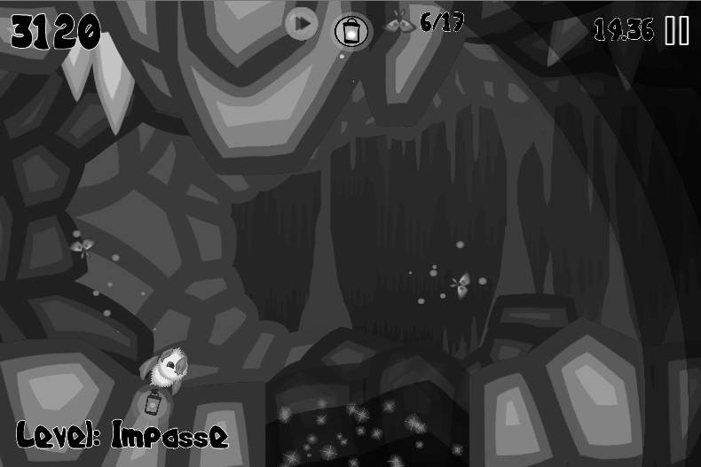

**Some examples in other games:**

I personally like this first one – it shows how the ground is a platform you can land on.

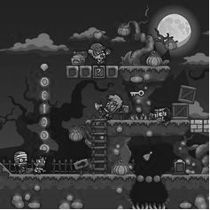

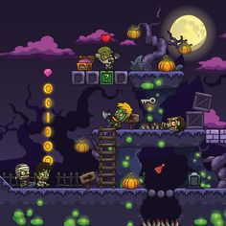

Clumsy Bat doesn’t use Cell shading, but the next example uses it well to show what you will collide with (i.e. the ground and platform), and what can be interacted with (i.e. the barrel in the top right). The roof and walls don’t use cell shading and it’s clear you won’t collide with them. It makes the ground “pop” in front of the background.

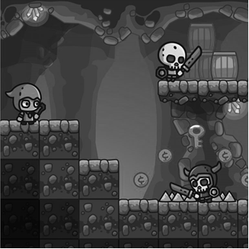

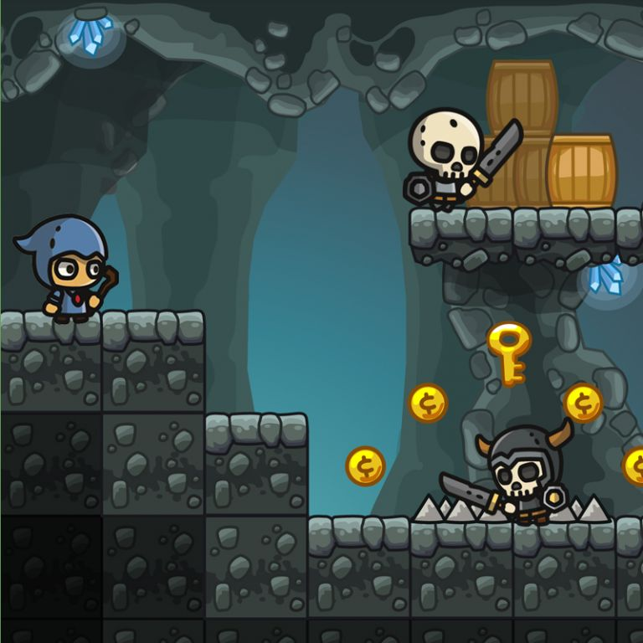

This next image uses decals (grass, spikes and mushrooms) to show what you can stand on or collide with.

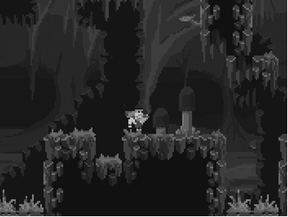



This last example uses a really light background to give a nice contrast:

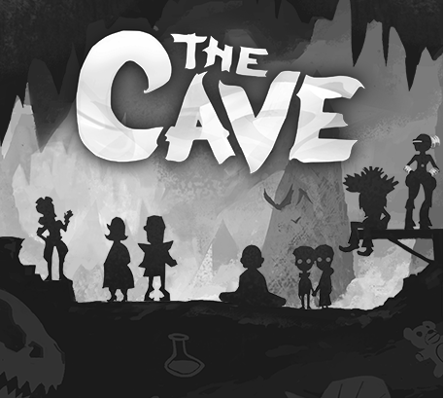

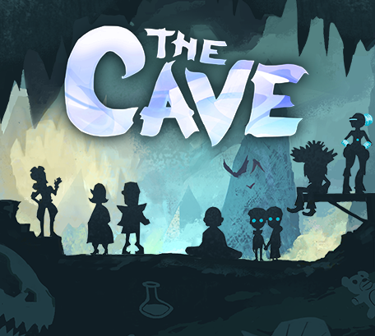

**Feedback 2:** *The cave’s exit looks like something I’ll crash into*

**Solution:** Differentiate the exit’s background from the foreground.

This is a similar point to the one above. Almost everyone has commented on this. While it’s less of an issue that you can just power through, it raises some doubt amongst players.

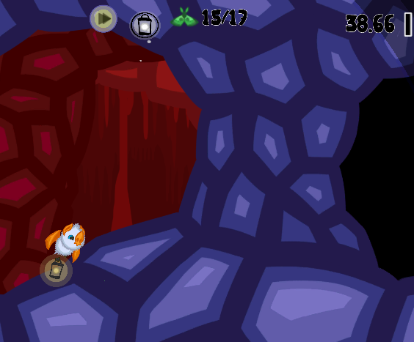 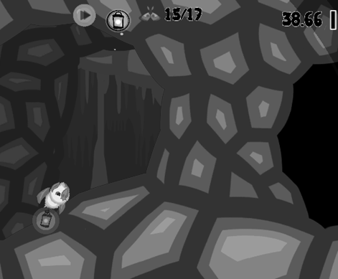

**Feedback 3:** *It should be obvious that a “secret path” is good to go down, when you find one (particularly if it’s a core game component)*

**Solution**: Entice the player to go down secret paths

This is more a game mechanic, but there’s a lot I don’t like about the following image. I’ll detail below! If you have an artistic idea, I think this could use it, otherwise I’ll add static moths down the path.

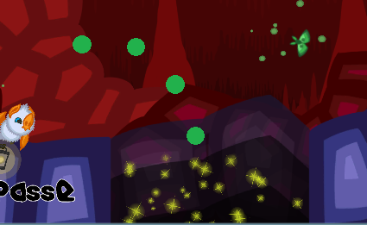

The stars are a placeholder I made that don’t suit the art style. I thought it might be a good way to say “look, shiny!” Most players go down it, while others voiced out loud “oh that’s probably something I want to avoid”

Some good feedback I got was to use Donkey Kong Country’s method of leading the player through or to a secret entrance. I couldn’t find a screenshot of DKC but here’s one from tropical freeze with bananas leading into an entrance – it looks so inviting!

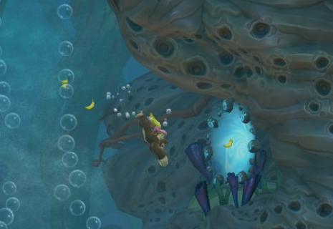

**Feedback 4:** *UI could be clearer*

**Solution:** I don’t really have a solution for this – I’m learning UI design in games!

There’s not *heaps* the UI is trying to convey, but it does need some improvements. Here’s what’s going on (left-to-right, top-to-bottom):

1. The score in the top left counts up (or down) as the player progresses through the level.
2. The arrows in the circle is a placeholder, indicating that Dash is ready. It has a radial cooldown indicator overlay
3. The lantern in the middle indicates that an optional tooltip/dialogue is available if tapped
4. The moth counter shows the number of moths collected / number of moths in the level
5. The timer in the top right counts up when the game is un-paused
6. The Pause button brings up the in-game pause menu
7. The Tooltip Text box (aka dialogue) is shown in conjunction with clumsy
8. The level in the bottom left shows the current level’s name

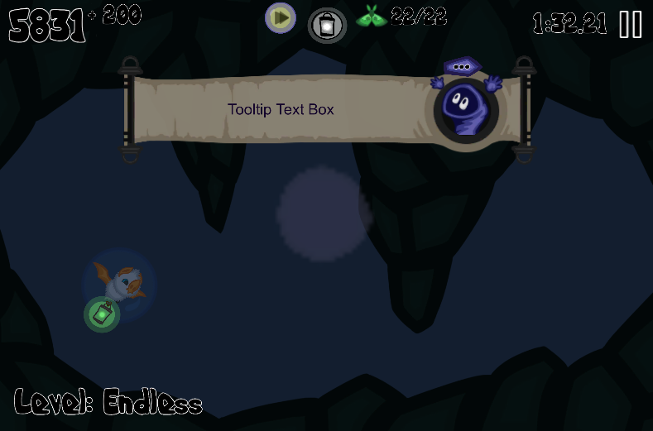

The score needs to be streamlined and is dependent on:

* Distance travelled (adds to score)
* Time taken (detracts from score)
* Moths collected (adds to score)

The timer might be best placed near the score. Maybe the moths, too.

The dash and dialogue indicators need to be made clearer, or just repositioned (maybe on the side).

I plan on having the level be shown only at the start of the level, and maybe when it’s paused.

# Additional Art Assets

The following table summarises the additional art assets required for Clumsy Bat. Each asset is detailed below the table

|  |  |  |
| --- | --- | --- |
| **Asset Name** | **Scene** | **Description** |
| **List A** |  |  |
| All listed in feedback | Various | As described in the Feedback section above |
| Main menu buttons | Main menu | Used for main menu buttons (Play, options etc) |
| Crystal level button | Main menu | Used in the level select – indicates a crystal puzzle level |
| Nomee button | Main menu | Used in the level select – indicates the Nomee level |
| **List B** |  |  |
| Dash button | In-Game | Indicates when dash is available for use |
| Normal level button | Main menu | Used in the level select – indicates a normal level |
| Crystals | Crystal level | Used in special levels to store moth essence |

## List A

### Main Menu Buttons

The 4 buttons in the main menu need a button prefab (or two)

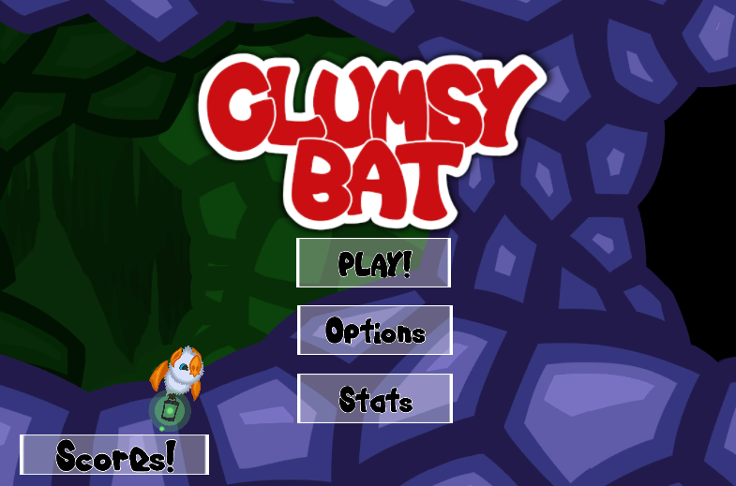

For example (but fitting to the game style of course):

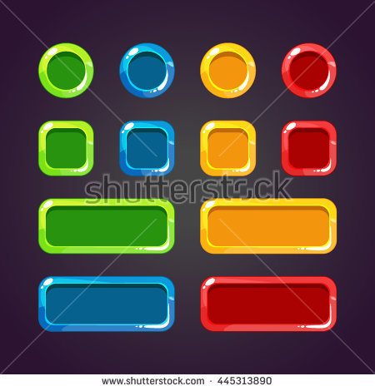

Some good examples from other games:

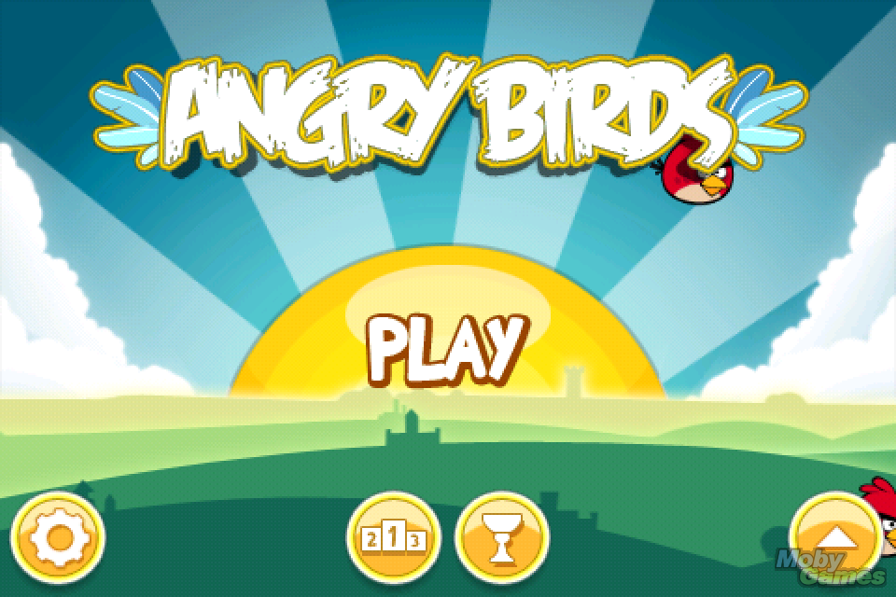 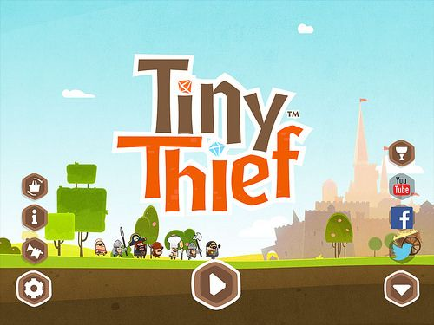

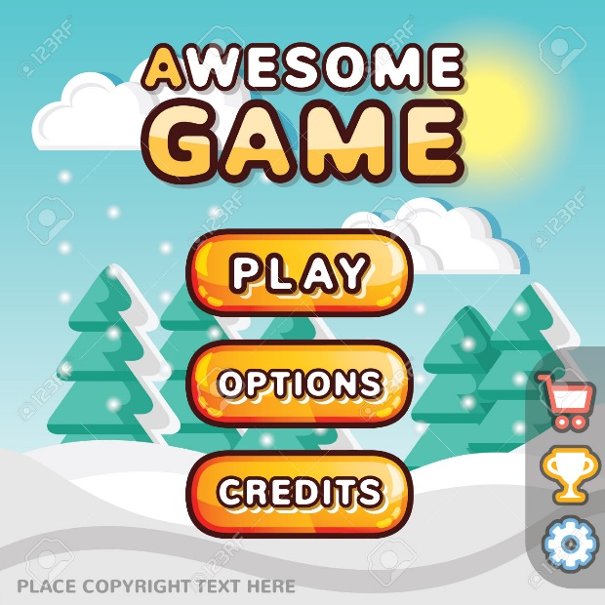

### Crystal Level Button

The level select screen below shows the current buttons used for the various levels.

The green button’s level is actually a crystal level, but uses the Rockbreath icon. Crystal levels (or shrines) unlock abilities such as hypersonic and dash.

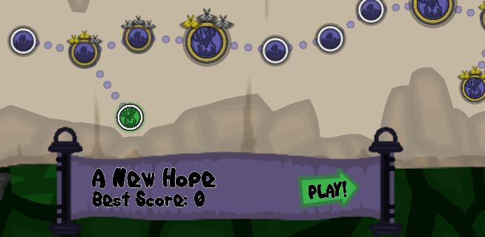

### Nomee button

As above, the final boss is Nomee (he was evil all along, just wanting you to collect all the essence and give it to him so he had all the power). He needs a level button like Rockbreath.

## List B

### Dash button

The dash button has a radial timer overlay to indicate the cooldown, and when it’s ready for use. Currently it’s not clear what it’s doing (see the UI section in feedback above). The current placeholders are as follows:

Cooldown, almost ready: 

Ready for use: 

### Normal Level Button

As with the other level buttons, the current icon is a village, and might be better as a cave? No players have commented on this, hence list B and would be nice to polish.

### Crystals

Crystals are used in two parts of the game:

1. Crystal levels

The crystal level works by the player activating the crystals in a specified order.

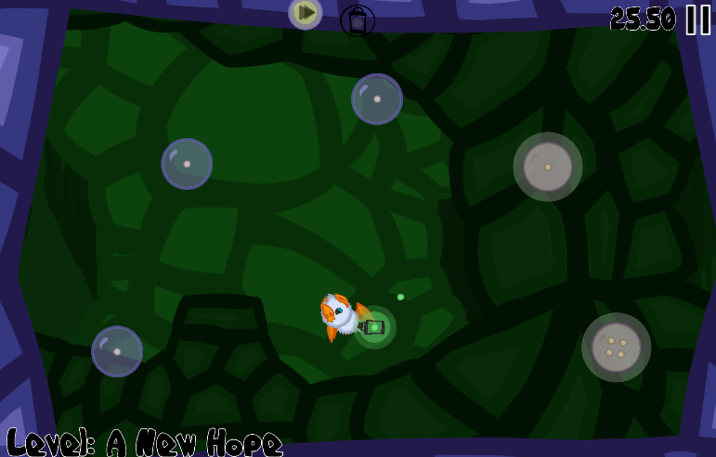

1. Boss fights

Rockbreath (king rockbreath, rockbreath jr, etc) can only be defeated by using hypersonic. The best way I found to introduce hypersonic into the level was to have him spit crystals at you (i.e. he ate them all and when he spits rocks, he sometimes spits out moth essence)

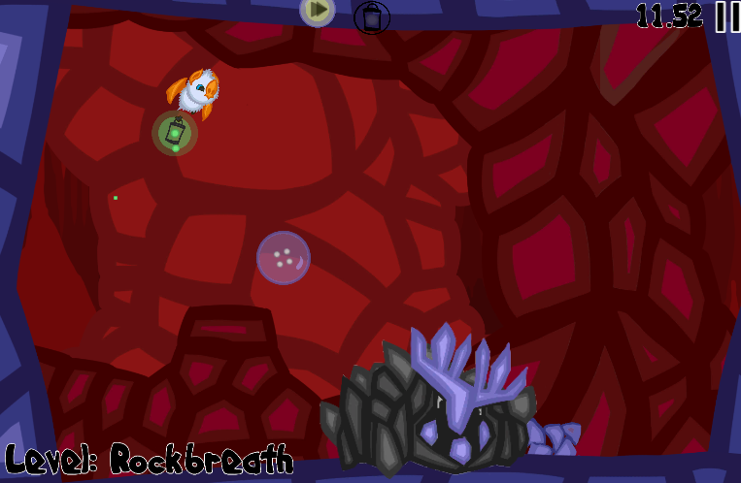

Collecting a crystal in a boss fight shatters it. Clumsy collects the essence and hypersonic is activated.

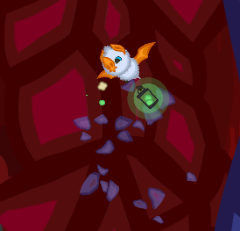

The crystals are functional, but I think they could use a redesign

# Document Control

|  |  |  |  |
| --- | --- | --- | --- |
| **Version** | **Comments** | **Author** | **Date** |
| 1 | Initial Version | Dan Szabo | 29-Oct-2017 |